Software article

Orbit-U: The Monitor – a provenance-aware PostGIS database and processing pipeline that harmonises Sentinel-1, MODIS and GPM IMERG into sub-district time series
Muhammad Faiq Hakim Ulinnuha^{1*} · [Supervisor name]¹
¹ Department of Information Systems, Faculty of Engineering and Informatics, Universitas Multimedia Nusantara, Tangerang, Banten, Indonesia
Corresponding author: Muhammad Faiq Hakim Ulinnuha, e-mail:[to be completed]
ORCID
Muhammad Faiq Hakim Ulinnuha: [16-digit ORCID, to be completed]
[Supervisor name]: [16-digit ORCID, to be completed]
Acknowledgements The authors thank the chairman and volunteers of Gugus Mitigasi Lebak Selatan for the interview and the requirements review, and all participants of the user trial.
Abstract Open Earth observation archives are easy to download but hard to keep: synthetic aperture radar scenes, optical composites and gridded precipitation differ in format, resolution and revisit time, and once they are processed the link between a reported number and its source file is usually lost. This article presents Orbit-U: The Monitor, an open-source PostgreSQL/PostGIS database with a Python processing pipeline that harmonises Sentinel-1, MODIS and GPM IMERG into one daily time series per administrative sub-district. Rasters pass through seven ordered artefact tiers and are reduced to sub-district values by zonal aggregation weighted by cell–polygon overlap, together with the valid fraction of each polygon. Eleven variables are stored as rows of a single observation relation, so that new variables require no schema change. Every file is registered with a SHA-256 checksum and every transformation as an edge of a lineage graph, so that any value can be traced to its raw scene. Idempotent upserts with an explicit precedence of GPM runs, advisory locks and catch-up logic make the pipeline restartable, and role-based access control is enforced inside the database. Deployed for ten sub-districts of South Lebak, Indonesia, the database holds 72 850 observations from January 2024 to October 2026; it passed 1183 of 1185 automated tests and recovered exactly after backup restoration and process kills.
Keywords Earth observation data harmonisation · Data provenance · Spatial database · PostGIS · Zonal statistics · Sentinel-1

1 Introduction
Open access to Earth observation (EO) data has changed what small organisations can monitor. The Copernicus Data Space Ecosystem distributes Sentinel data through application programming interfaces and cloud processing (Kovács et al. 2026); MODIS offers more than two decades of daily observations with continuity into VIIRS (Román et al. 2024); and GPM IMERG provides global precipitation estimates whose long-term behaviour over land is well documented (Zhu et al. 2025). For hydrometeorological hazards the three missions are complementary: Sentinel-1 synthetic aperture radar (SAR) detects open water regardless of cloud cover (Misra et al. 2025; Tarpanelli et al. 2022; Tran et al. 2022), MODIS describes surface water and vegetation on cloud-free days (Klein et al. 2024), and IMERG describes the rainfall that drives both, which matters where rain gauges are sparse (Ansori and JBS 2026; Hidayah et al. 2024).
Using the three missions together is, however, an informatics problem before it is an analytical one. The products arrive as GeoTIFF, HDF4-EOS, HDF5 or NetCDF, at about 10 m to 0.1°, every day or every 6–12 days, and with run types or quality flags that may later be superseded. Existing open tools concentrate on producing analysis-ready images, for example Sentinel-1 preprocessing pipelines or analysis-ready data cubes (Upadhyay et al. 2022; Weiß and Fincke 2022), and multi-sensor studies typically analyse a single event (Castro-Melgar et al. 2025; Liu et al. 2023). What is rarely addressed is the persistent layer behind such work: a database in which the outputs are stored in a comparable form, revised when better inputs appear, and traceable to the files and parameters that produced them. In data engineering, lineage is increasingly treated as metadata that the pipeline itself must record (Gopaluni 2025), and PostGIS has been shown to outperform general relational approaches for spatial storage and queries (Kaptosv 2025; Papasani and Papasani 2025), but these strands have not been combined for multi-mission EO time series.
This article describes Orbit-U: The Monitor, an open-source system built for Gugus Mitigasi Lebak Selatan (GMLS), a community disaster mitigation group in Banten, Indonesia, whose earlier information work concerned earthquakes and tsunamis (Tilung et al. 2025; Wong et al. 2024) and which had no hydrometeorological data of its own. The contributions are (1) a harmonisation procedure that reduces three missions to one sub-district time series with an explicit valid-coverage measure; (2) a long-format data model in which variables are data rather than columns; (3) provenance recorded by the pipeline as checksummed products and lineage edges; (4) a restartable pipeline whose writes are idempotent and whose revisions follow a stated precedence; and (5) role-based access control enforced in the database rather than only in the application. The design followed the Database System Development Life Cycle and is evaluated by automated tests, a DBMS benchmark, recovery experiments and a user trial.

2 Design and implementation

2.1 Requirements
Requirements were derived from observation of GMLS, an interview with its chairman, examination of its documents and data, and a literature study, and were confirmed by a requirements review questionnaire answered by the chairman and two volunteers. Expressed in informatics terms, the system had to (R1) integrate the three missions into one unit of analysis; (R2) record every output file with its checksum and the transformation that produced it; (R3) measure data quality and flag values below a threshold; (R4) generate rainfall warnings from stored values and record who acknowledged them; (R5) archive disaster events with source and verification status; and (R6) restrict data by role and audit changes. Demographic and evacuation data remain in an existing village application and are outside the database.

2.2 Study area and input data
The unit of analysis is the sub-district (kecamatan). Ten sub-districts in the south of Lebak Regency were selected with GMLS (Fig. 1); their boundaries come from the Indonesian COD-AB dataset (OCHA n.d.) and cover 1575.8 km², from about 94.9 km² (Cilograng) to 400.8 km² (Cibeber). The input products are listed in Table 1. Because the sources cannot be compared pixel by pixel, the polygon rather than the grid cell is the common denominator of all stored values.
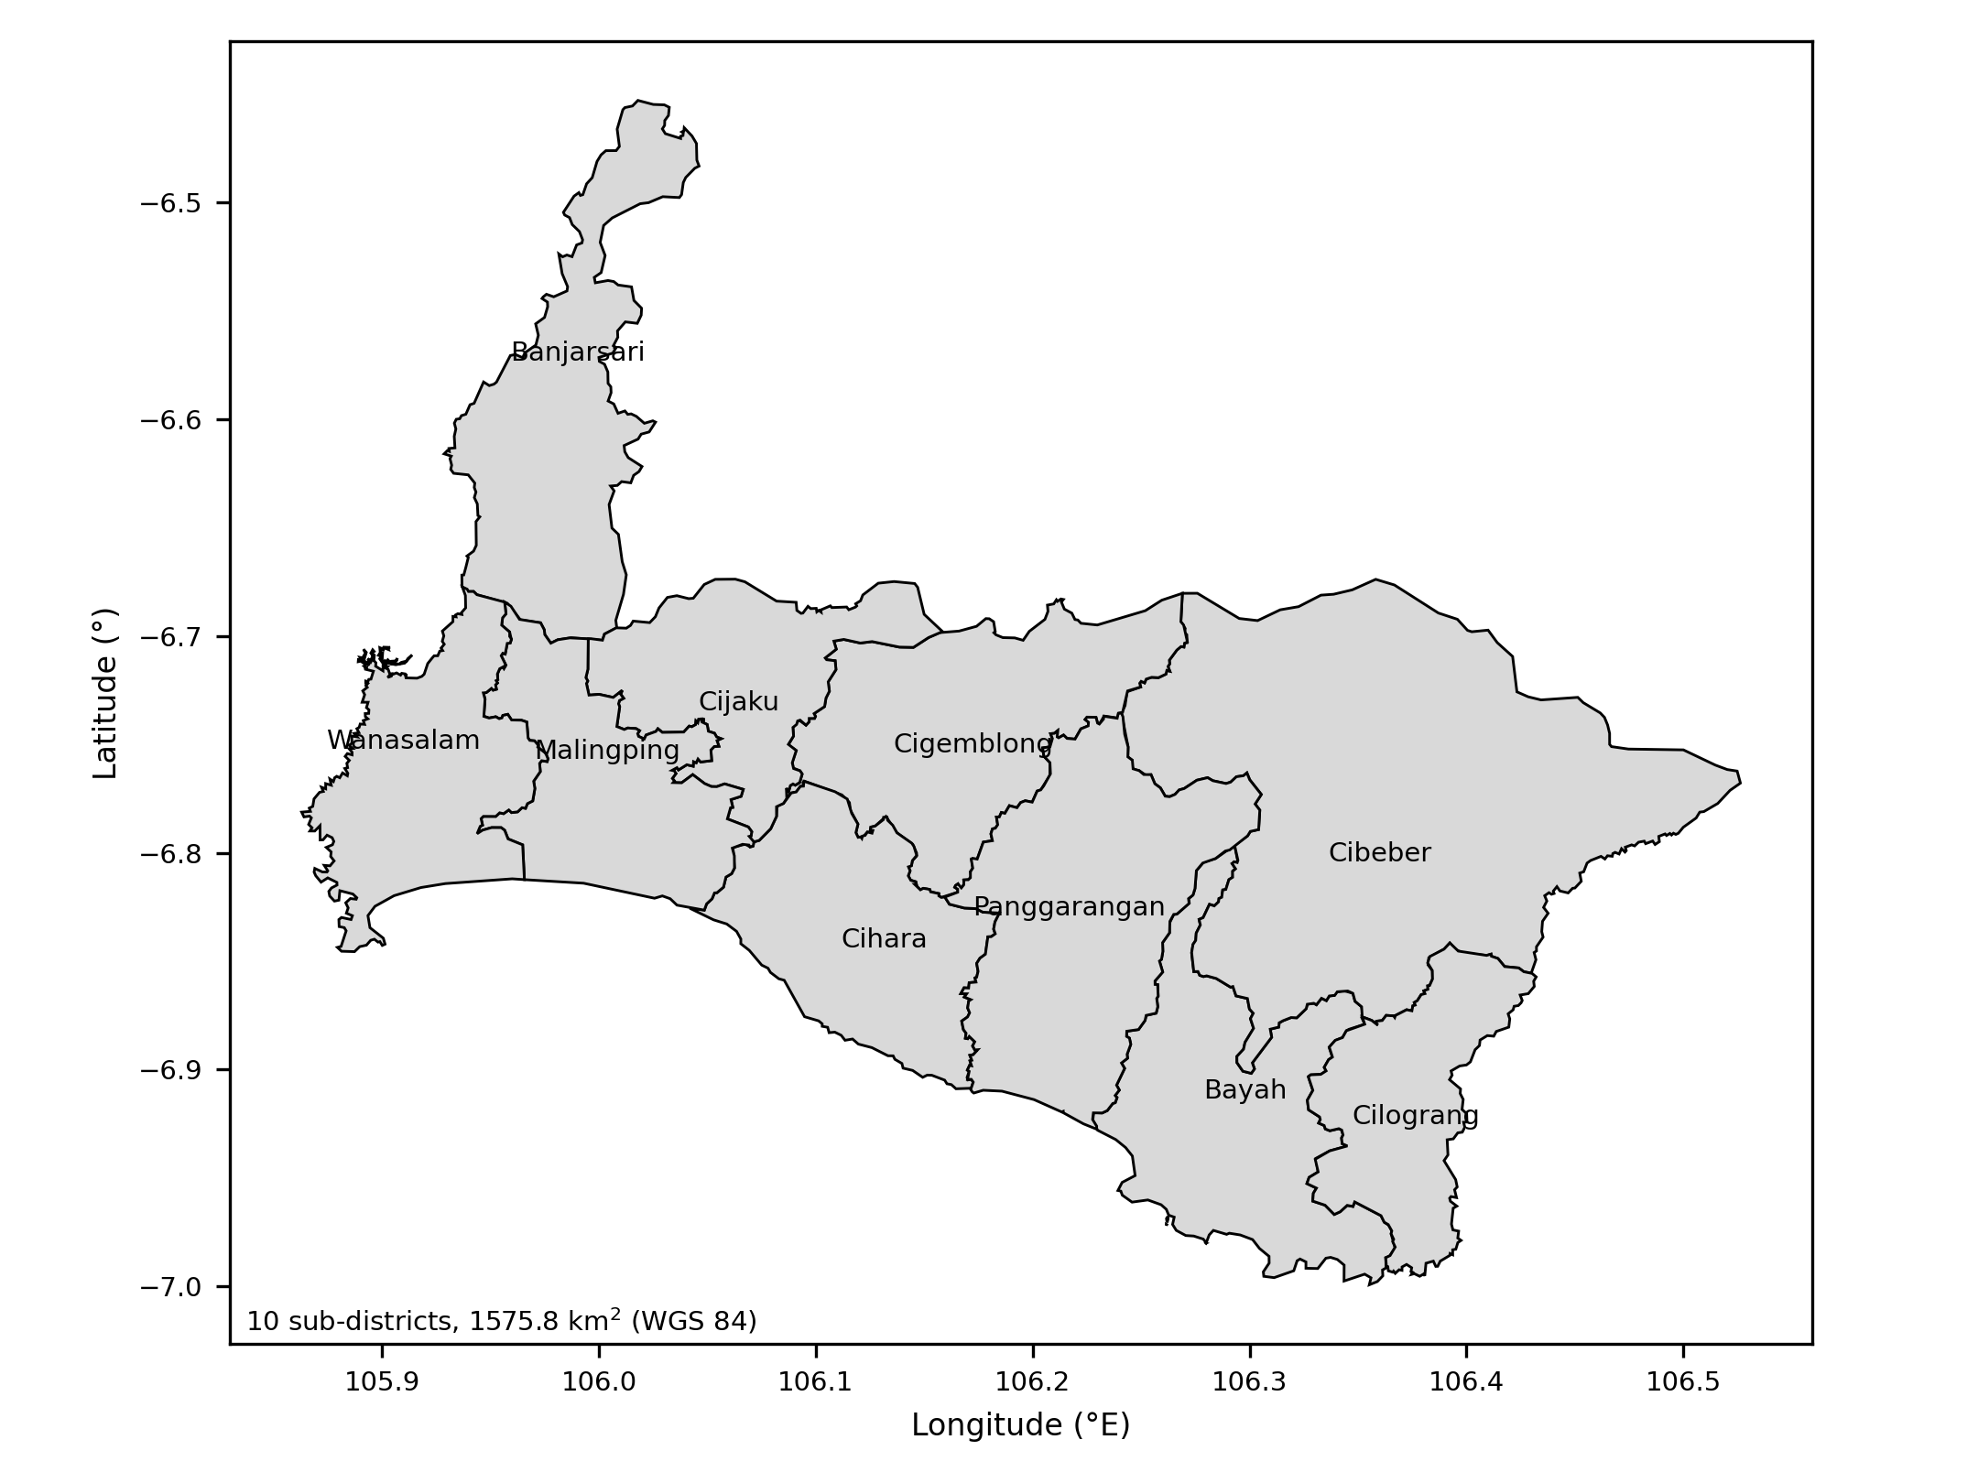
Fig. 1 Study area: ten sub-districts of South Lebak, Banten, Indonesia (Based on COD-AB boundaries (OCHA n.d.))
Table 1 Satellite data sources (Based on (Román et al. 2024; Tarpanelli et al. 2022; Zhu et al. 2025))
Mission | Products | Resolution | Frequency | Provider
Sentinel-1 (S1A, S1C, S1D) | GRD IW, VV and VH polarisation | ≈10 m | 6–12 days per orbit | ESA, CDSE
MODIS Terra and Aqua | MCDWD flood; MOD09A1, MOD09GA (NDVI, NDWI) | 250–500 m | Daily; 8-day composite | NASA LANCE, LAADS DAAC
GPM IMERG | Daily Final, Late and Early runs | 0.1° | Daily | NASA GES DISC

2.3 Processing pipeline and artefact tiers
Each mission is processed through ordered artefact tiers (Fig. 2). RAW holds the vendor file. ALIGNED holds the product reprojected to EPSG:4326 and cropped to the area of interest; for Sentinel-1 this already includes radiometric calibration to σ⁰, because uncalibrated digital numbers have no physical meaning. DESPECKLED applies a 7×7 Lee filter to SAR; INDICES holds MODIS NDVI and NDWI (McFeeters, green/NIR) after removal of cloud, shadow and cirrus pixels; and ACCUMULATED holds IMERG totals over 24 h, 72 h, 7 days and 30 days. Every band then becomes a Cloud-Optimised GeoTIFF (COG), and an optional FUSED tier stores multi-sensor HDF5. MODIS flood fraction is taken from the daily MCDWD product (two-day composite, 250 m) and vegetation and water indices from MOD09A1 (eight-day, 500 m) with MOD09GA as daily fallback. For IMERG, the Final, Late and Early runs are tried in that order and the run used is stored with each value.
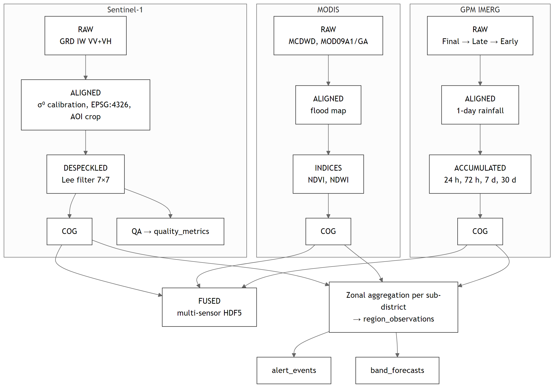
Fig. 2 Processing tiers per mission and the path of values to the database
Raster files are kept in the file system; the database stores their metadata, location and checksum. Rasters of the operational dataset are retained for 365 days, whereas sub-district values are kept indefinitely. A product whose file has been removed is marked invalid instead of deleted, so that its lineage remains readable. Separating heavy, regenerable files from light, permanent values keeps the database small while preserving the record of how every value was derived.

2.4 Zonal harmonisation
Sub-district values are computed in Python from the COGs. All cells touched by a polygon are selected, and each receives a weight equal to the planar area of its intersection with the polygon multiplied by the cosine of its latitude, which approximates the true area on the sphere. The value of band b for sub-district r on date t is the weighted mean of valid cells:
${x̄}_{r,b,t}=\frac{\sum_{c∈V_{r}}{w_{c}·x_{c}}}{\sum_{c∈V_{r}}{w_{c}}}, w_{c}=a_{r,c}·cosφ_{c}$ (1)
where a_{r,c} is the intersection area of cell c with polygon r, φ_{c} the latitude of the cell centre, x_{c} the cell value and V_{r} the set of valid cells. Overlap weighting matters for coarse grids: a 0.1° IMERG cell covers a sub-district with only one to six cells, so a cell that barely touches the polygon must not count fully. The valid fraction, the share of total weight carried by valid cells, is stored with each value; below 0.1 the value is stored as NULL rather than computed from a small cloud-free remnant, since optical pixels are frequently invalid under cloud cover (Tang et al. 2024). Flood fraction is computed analogously as the weighted share of MCDWD water classes.
Values are written with an upsert on the key (region, band, date) that replaces an existing value only if the new GPM run is not worse (Final over Late over Early) or the old value is NULL; a NULL never overwrites a value. Because IMERG Final appears about 3.5 months after observation, a weekly job recomputes dates in the last 153 days that still carry Late or Early values, and the upsert replaces them when Final is available. Revision thus needs no invalidation flags, and warnings already generated keep a copy of the value and threshold that triggered them.

2.5 Data model
The central relation region_observations (Fig. 3) has the alternate key (region_id, band_id, obs_date) and stores eleven variables as rows: VV and VH backscatter, water percentage and water change from Sentinel-1; flood fraction, NDVI and NDWI from MODIS; and 24-hour, 72-hour, 7-day and 30-day rainfall from IMERG. Each row also carries the valid fraction, the GPM run type and the identifier of the source product. Variables are described in spectral_bands, which defines physical limits that a trigger enforces, so that a processing error such as negative rainfall is rejected at insertion. Adding a variable is therefore an insertion into spectral_bands, not a schema migration.
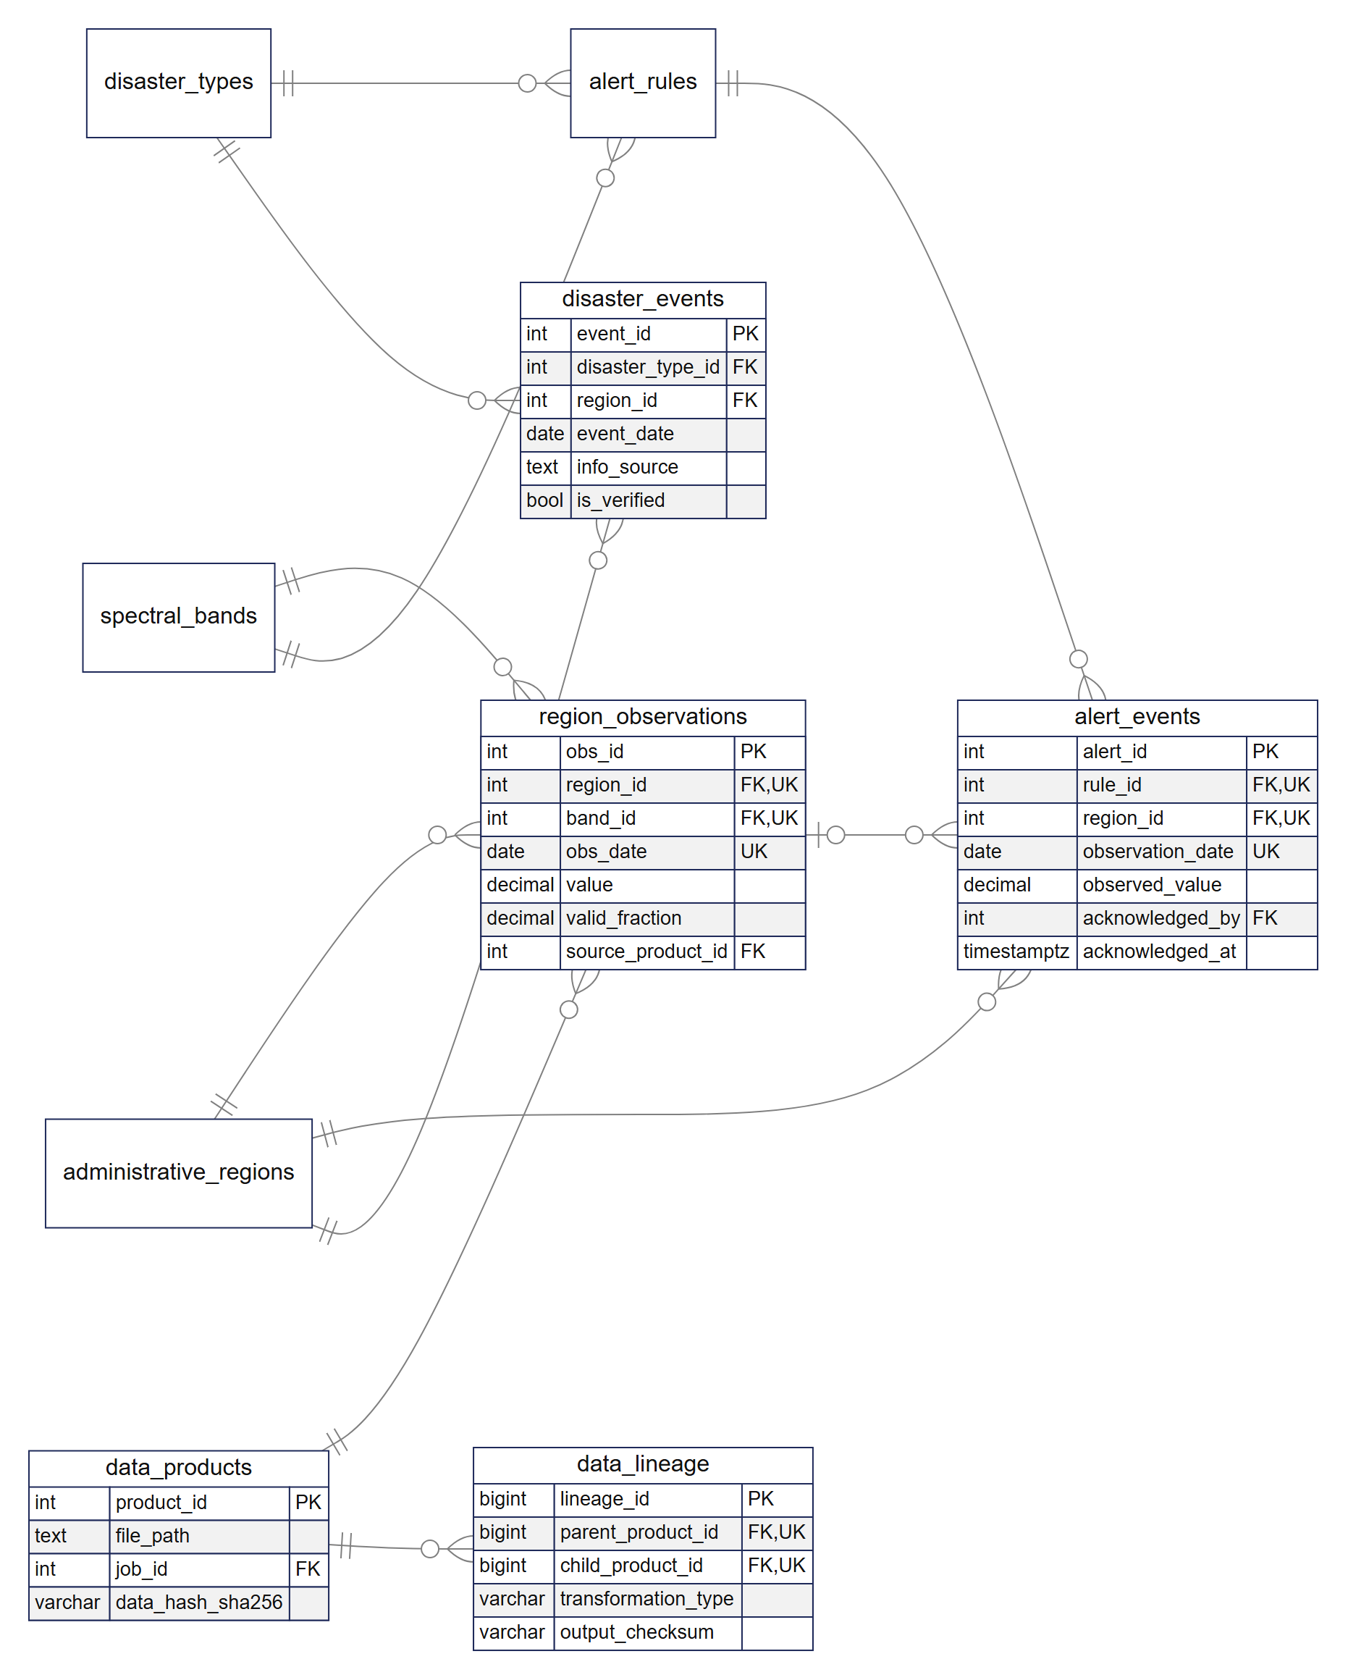
Fig. 3 Core relations for observations, lineage, warnings and events (crow's foot notation)
The model was obtained by normalising an observation record that repeated sub-district, regency, band, unit and satellite in every row; moving these attributes to their own relations, with the regency as a recursive reference among administrative regions, yields third normal form, and selected relations were checked against Boyce–Codd and fourth normal form (Skavantzos and Link 2025; Zhang and Link 2025). Integrity rules are declared in the database rather than inferred from application code (Huang et al. 2023; Kanwal et al. 2025): the implemented schema has 43 tables, 22 views, 80 foreign keys, 67 check constraints and 29 triggers. Indexes follow access patterns: GiST on boundaries, scene footprints and event locations; descending B-trees for the latest values of a series; a partial index on unacknowledged warnings; and two B-trees on lineage edges for traversal in both directions.

2.6 Provenance
Provenance is held by three relations (Fig. 4). data_products registers every file of every tier with its SHA-256 checksum; data_lineage stores each transformation (for example calibration, speckle filtering or COG conversion) as an edge from a parent to a child product with input and output checksums; and processing_jobs stores, for each stage, a JSON record of the software version, GPM run, accumulation window and thresholds used. A stored value is followed through source_product_id and a recursive query to the raw scene. Because edges carry checksums, a file altered after processing can be detected, and a doubtful value can be recomputed from its parent product without downloading the archive again. Quality metrics computed per scene are compared with configurable thresholds and raise quality alerts.
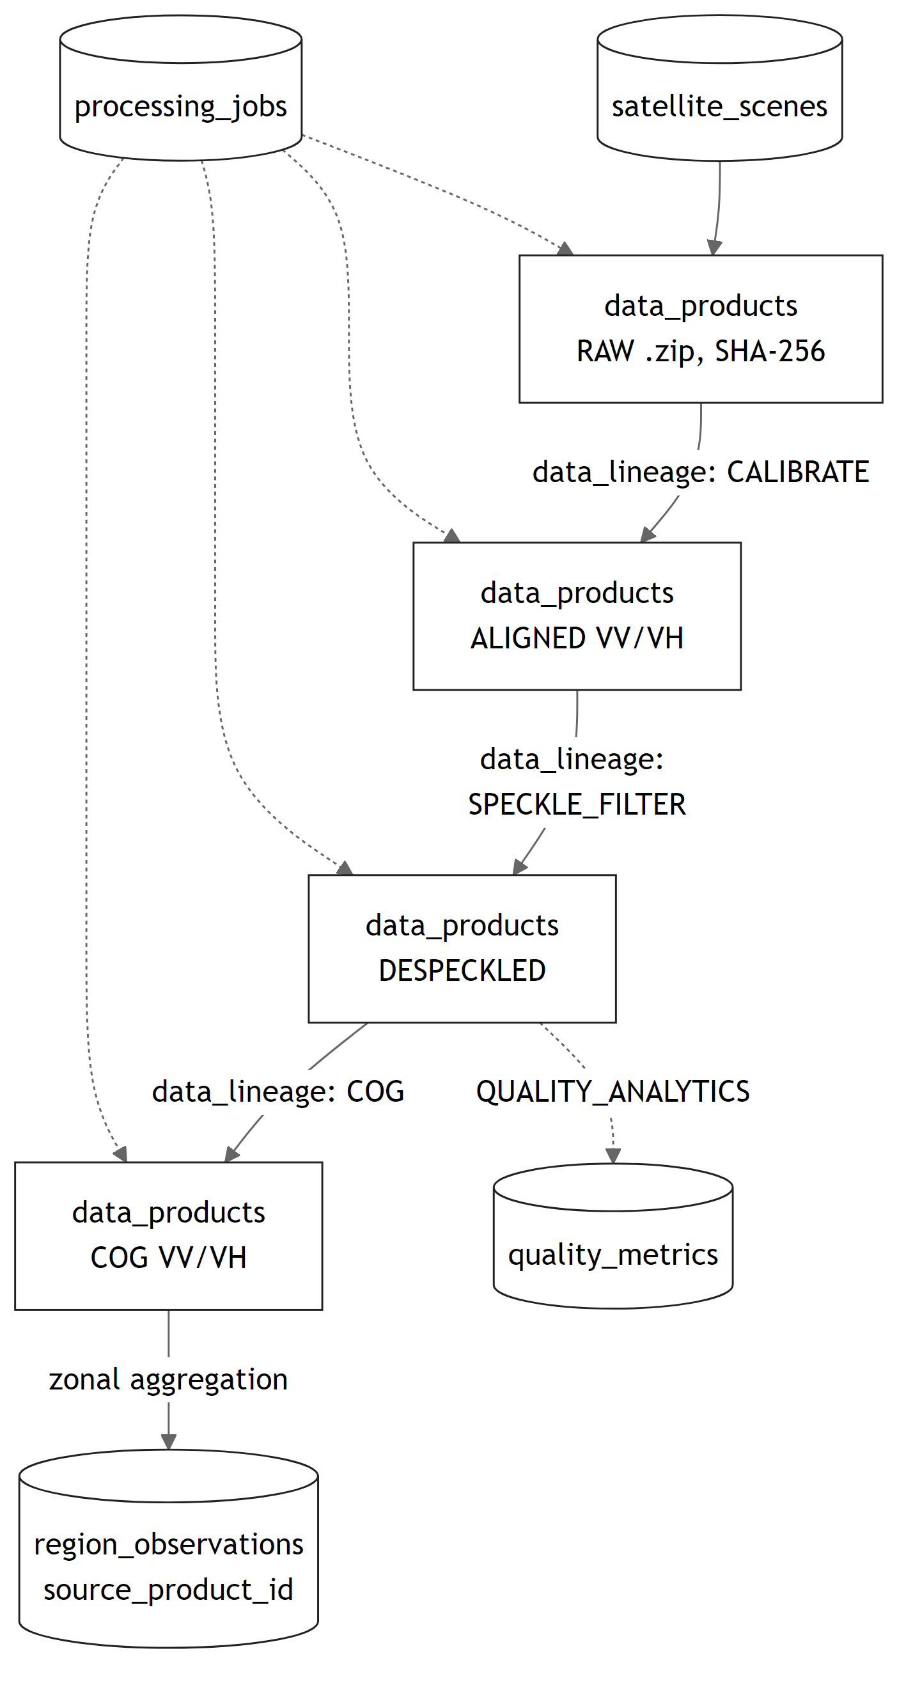
Fig. 4 Provenance of a Sentinel-1 value from scene to sub-district observation

2.7 Scheduling, locking and recovery
One scheduler runs the daily hydrometeorological job, the weekly Final refresh, a six-hourly Sentinel-1 cycle and periodic reports. Each job type takes a PostgreSQL advisory lock on a dedicated connection; a second worker that cannot obtain it records the run as SKIPPED_LOCKED, and the lock is released automatically if the process dies. The daily job processes GPM first, because warnings depend only on rainfall, and treats MODIS as non-fatal. Table 2 summarises how the pipeline reacts to the failures observed in operation; in every case recovery consists of running the same command again, because all writes are idempotent.
Table 2 Failure handling of the pipeline
Situation | Behaviour
GPM granule not yet published in any run | Date marked WAITING_UPSTREAM and retried at every schedule for up to 3 days, then FAILED
Daily job missed (process down at run time) | Missed dates up to 30 days are detected from the job table and processed at start-up and in the next daily run; older gaps are filled by backfill
MODIS unavailable | Non-fatal; the day completes with GPM values
Stalled download | Attempt cancelled when the mean rate stays below a threshold within a 90 s window; retry with HTTP Range resume
Pipeline killed mid-run | Completed dates are skipped, the current date is repeated; all writes are upserts or ON CONFLICT
Same job started twice | Advisory lock not obtained; run recorded as SKIPPED_LOCKED
Sentinel-1 scene only grazes the area | Marked INCOMPLETE and not retried

2.8 Access control and interfaces
Five application roles (visitor, volunteer, analyst, data engineer and administrator) map to PostgreSQL roles. The ETL connects as a dedicated role; the FastAPI REST API connects as a NOINHERIT role without privileges and switches with SET LOCAL ROLE to the role of the requesting user in every transaction. Views restrict the time window per role (visitors 30 days of imagery, volunteers 365 days), row-level security limits generated reports to their audience and API tokens to their owner, and one audit trigger function stores old and new rows as JSON. The approach extends GRANT-based role control in PostgreSQL (Purwitasari et al. 2025) with per-transaction role switching and row-level security. A web client presents the latest condition per sub-district, imagery, warnings based on the 50, 100 and 150 mm thresholds of the Indonesian meteorological agency, and disaster events.

2.9 DBMS selection procedure
PostgreSQL 18.6 with PostGIS 3.6.2 and MySQL 8.0.40 were compared on an equivalent schema with identical deterministic synthetic data (28 sub-districts, 76 720 observations) and default configurations. Five core queries were run 30 times after five warm-up runs in three separate runs, and medians are reported. Security features, scalability, concurrency and write throughput were also tested, and seven weighted criteria were scored from 1 to 5, the total being
$S=\sum_{i=1}^{7}{w_{i}·s_{i}}$ (2)
where w_{i} is the weight and s_{i} the score of criterion i. An AI assistant was used in preparing this manuscript as described in the Declarations; it was not used to produce data or results.

3 Results

3.1 Deployment and stored data
The system is deployed with the architecture shown in Fig. 5. Loading started from an empty database: schema, security objects and reference data were applied in order, the COD-AB boundaries were loaded, and GPM, MODIS and Sentinel-1 data were backfilled through the same code path as the daily jobs. As of 24 October 2026 the database held 72 850 sub-district observations from 1 January 2024 to 22 October 2026, 15 850 data products, 8142 lineage edges, 7958 processing jobs and 210 warnings derived from the observations. Such multi-year records are a precondition for interpreting the behaviour of an area (Halder et al. 2023).
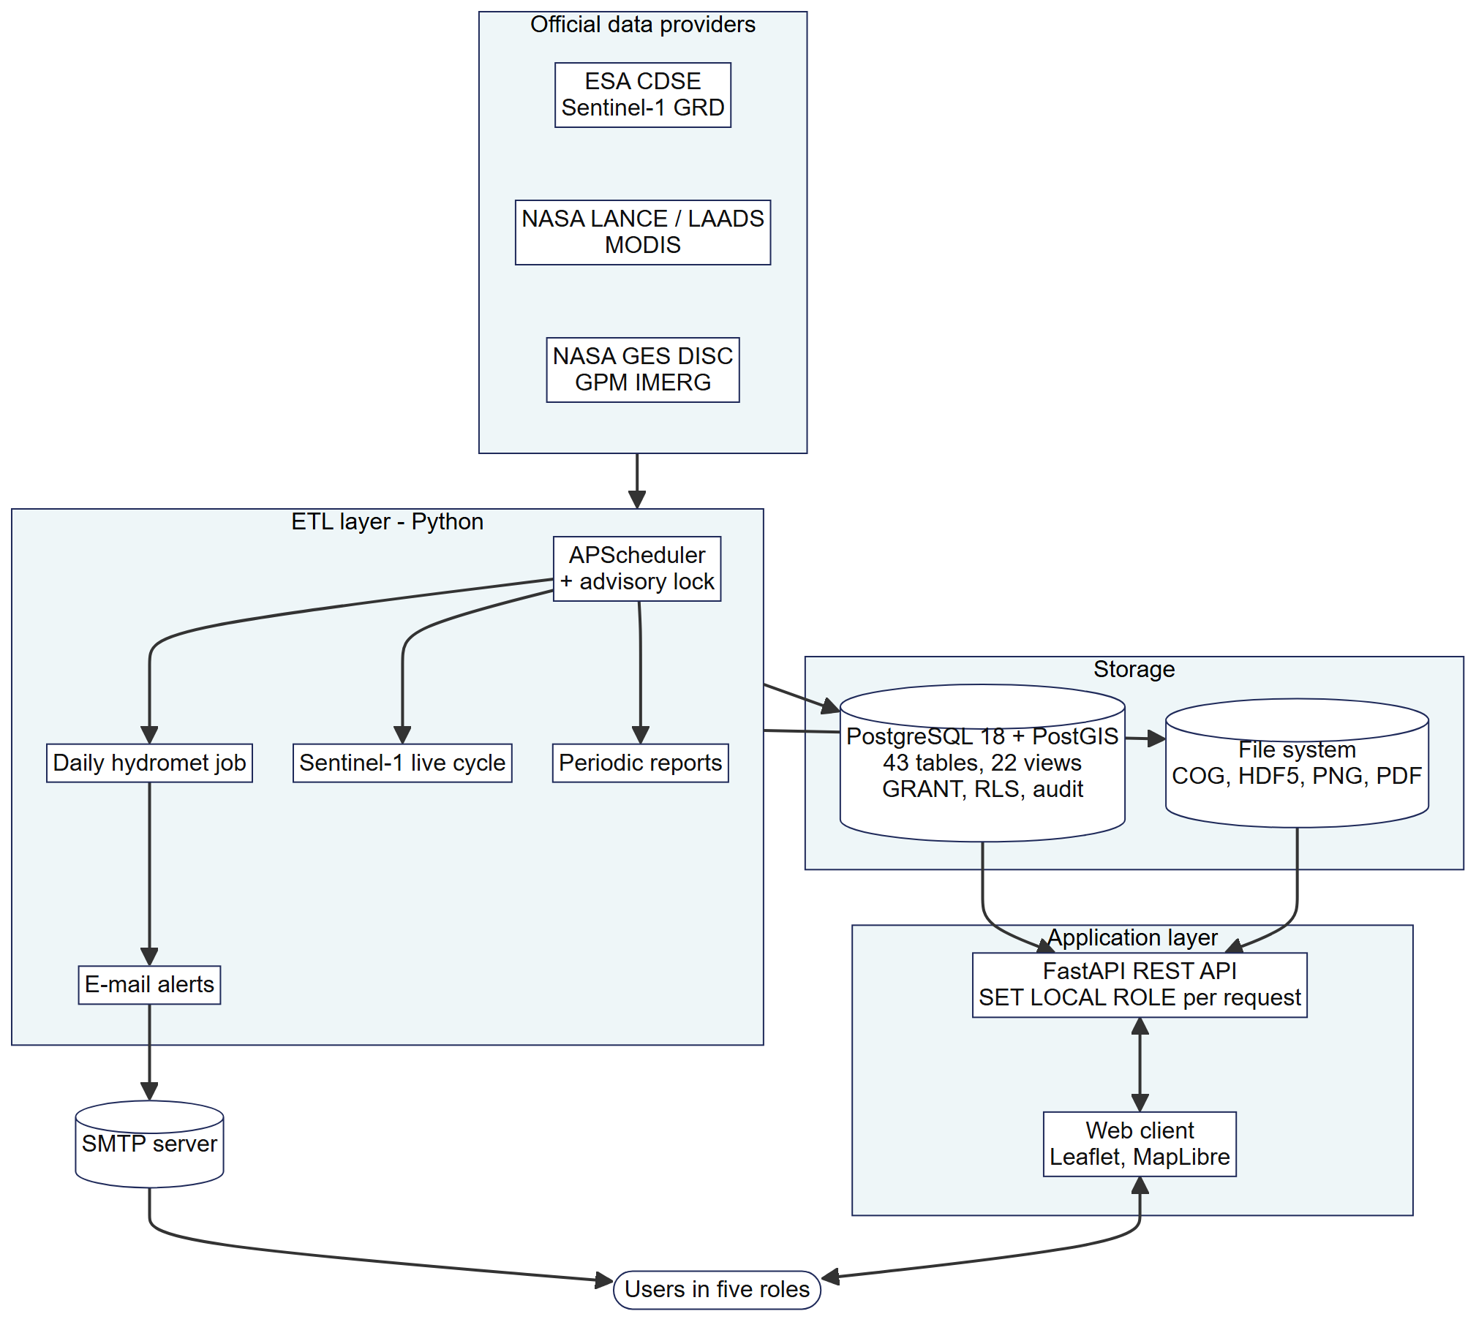
Fig. 5 Deployment architecture

3.2 DBMS comparison
PostgreSQL was faster in four of five core queries (Table 3, Fig. 6), most clearly for polygon intersection with area computation (Q3, 17×) and for the evaluation of warnings against events (Q4, 9×). The equivalent Q3 failed in MySQL with error 3516 because the geographic intersection produced a GeometryCollection and had to be rewritten. MySQL was faster in the recursive lineage query Q5, although both completed below 1 ms. Result rows were identical, and Q3 areas agreed within 0.1% per sub-district. Over 2.3 million rows a summary query took 654 ms in PostgreSQL and 5577 ms in MySQL, and inserts were 8.2 times faster in PostgreSQL.
Table 3 Median execution time of core queries [ms]
Query | Content | PostgreSQL | MySQL | MySQL/PG
Q1 | Rainfall pivot per sub-district, one date | 0.45 | 1.14 | 2.5×
Q2 | 30-day trend, one sub-district and band | 0.29 | 0.67 | 2.3×
Q3 | Polygon intersection with geodesic area | 1.34 | 22.57 | 17×
Q4 | Warning evaluation: hits, misses, false alarms | 1.76 | 16.64 | 9×
Q5 | Six-level lineage (WITH RECURSIVE) | 0.82 | 0.43 | 0.5×

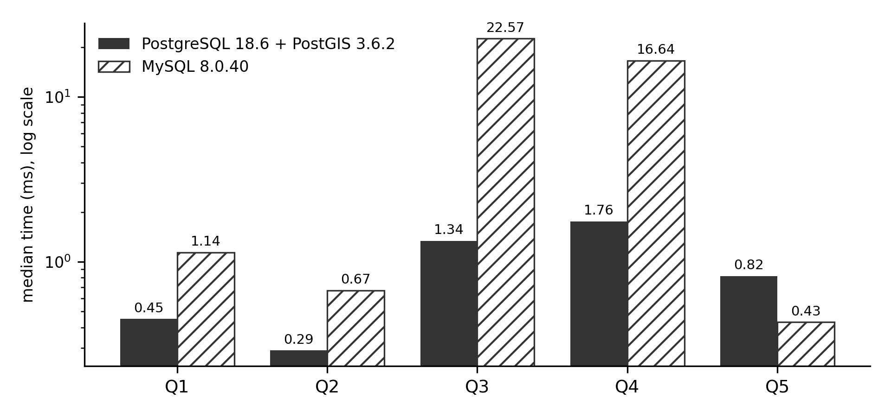
Fig. 6 Median execution time of core queries (logarithmic scale)
The decision rested on functional rather than temporal differences (Table 4): MySQL 8.0 switches roles only per session, lacks row-level security and requires one audit trigger per table. PostgreSQL scored 4.90 and MySQL 2.90. Because the PostgreSQL data resided on an SSD and the MySQL data on an HDD, MySQL was additionally given the maximum score on the two storage-sensitive criteria; its total rose to 3.55, which did not change the outcome.
Table 4 Weighted scores of the DBMS selection
Criterion | Weight | PostgreSQL | MySQL | Basis
Role-based security and audit | 25% | 5 | 2 | F1–F3
Spatial queries | 20% | 5 | 2 | Q3 17×, error 3516
Analytics and scale | 15% | 5 | 2 | Q4 9×, 2.3 M rows 8.5×
ETL writes | 10% | 5 | 3 | Insert 8×, upsert 2×
Concurrent reads | 10% | 5 | 4 | 13–26%
Relational and recursive integrity | 10% | 5 | 5 | Both support FK
Cost, ecosystem, familiarity | 10% | 4 | 5 | MySQL used locally
Total | 100% | 4.90 | 2.90

3.3 Verification and recovery
Table 5 summarises the evaluation. The final automated run executed 1185 test cases: 1183 passed, none failed, and 2 were skipped because they need the full boundary shapefile. All core queries completed below 2 ms, and the system reached 8523 queries per second with eight clients. A copy of the production database (44 tables, 146 541 rows) was dumped and restored, after which the MD5 hashes of all rows, sequences, constraints and 163 indexes were identical (Ahmad and Panda 2024). A backfill of ten dates killed with SIGKILL resumed only the two remaining dates, without duplicates or wrong values, in three of three repetitions, and a job started while its lock was held was skipped as designed.
Table 5 Results of the six minimum evaluations
Evaluation | Evidence | Result
Requirements review | Questionnaire, three GMLS respondents | Approved (two with revisions)
Integrity | Schema, constraint, comment and audit tests | Passed
Functional | Black-box scenarios through the REST API | Passed
Security | 165 API cases, GRANT matrix of 390 cells | Passed
Query | Benchmark Q1–Q6, concurrency, writes, F1–F3 | All core queries < 2 ms
Backup/recovery | Dump and restore, process kill and resume | Passed; identical MD5

GMLS approved the design, two of three respondents with revisions; the main request, notification through mobile messaging instead of e-mail, was not implemented because of per-message costs, although the subscription tables do not depend on the channel. In a user trial, 13 lay respondents made 67 attempts at six tasks, of which 62 (92.5%) succeeded, with a mean ease rating of 4.36 out of 5.

4 Discussion
Three design decisions carry most of the system. First, storing values rather than rasters in the database, with rasters as regenerable files, kept the database small enough to restore in seconds while preserving an indefinite time series; the cost is that raster-level questions must return to the files or the providers. Second, the long format with physical limits per band turned the addition of a variable into data entry and allowed one key, one upsert rule and one warning engine to serve all eleven variables. Third, recording provenance inside the pipeline, as recommended for metadata-driven ETL (Gopaluni 2025), made traceability a by-product of normal operation rather than a reconstruction effort, and the stated precedence of GPM runs made revision of near-real-time values a routine, auditable step.
Compared with preprocessing tools and data cubes (Upadhyay et al. 2022; Weiß and Fincke 2022), the system adds persistence, revision and provenance at the level of administrative units, which is the level at which local organisations act. Compared with work on integrated geospatial databases (Dev et al. 2023) and role control in PostgreSQL (Purwitasari et al. 2025), it enforces access in the database, so that unauthorised queries were rejected in tests even with the API checks disabled.

4.1 Limitations
Area weights use the planar intersection area scaled by the cosine of latitude, an approximation of geodesic area that is adequate at 6–7° S but not exact. The water change map uses a fixed VH threshold of −20 dB rather than an adaptive method such as Otsu (Tran et al. 2022), so smooth surfaces may appear as water and flooded vegetation as land. IMERG underestimates extreme daily rainfall (Ansori and JBS 2026), and warnings inherit this. A view that classifies hits, misses and false alarms exists, but no verified official hydrometeorological events were available for the study area, so warning skill could not yet be quantified. Point-in-time recovery was not tested because WAL archiving was not enabled, and the benchmark used synthetic data and default configurations.

5 Conclusions
Orbit-U: The Monitor shows that a relational spatial database can serve as the persistent, traceable layer behind multi-mission EO monitoring. Sentinel-1, MODIS and GPM IMERG are harmonised into one sub-district time series by overlap-weighted zonal aggregation with an explicit valid fraction; variables are rows, so the schema is stable; every value is linked by checksums and lineage edges to its raw scene; revisions follow a stated precedence through idempotent upserts; and access control and auditing are enforced in PostgreSQL/PostGIS, which was selected over MySQL 8.0 with a weighted score of 4.90 against 2.90. The design passed automated, security and recovery tests and has been operating with real data since 2024. Future work includes adaptive water thresholds, exact geodesic weights, evaluation of warning skill as verified events accumulate, mobile notification, and continuous WAL archiving.

6 Availability and requirements
Project name: Orbit-U: The Monitor
Project home page: https://github.com/not-notyou-you/orbit_u_monitor
Running instance: https://orbit-u.hakimhakim.workers.dev/
Operating system(s): Platform independent (developed on Windows 10, deployed on Linux)
Programming language: Python 3.10, SQL (PL/pgSQL), JavaScript
Other requirements: PostgreSQL 18 with PostGIS 3.6 and pgcrypto; Python packages listed in requirements.txt (FastAPI, SQLAlchemy, GeoAlchemy2, rasterio, shapely, pyproj, h5py, pyhdf, APScheduler); Copernicus Data Space Ecosystem and NASA Earthdata accounts for data download
Hardware requirements: [to be completed: minimum server specification used in deployment]
License: [to be completed: the repository does not yet contain a licence file; an open licence for non-commercial use is required for software articles]

Abbreviations
AOI Area of interest
API Application programming interface
COD-AB Common Operational Datasets – Administrative Boundaries
COG Cloud-Optimised GeoTIFF
DBMS Database management system
EO Earth observation
ETL Extract–transform–load
GMLS Gugus Mitigasi Lebak Selatan
GPM IMERG Global Precipitation Measurement Integrated Multi-satellitE Retrievals for GPM
MODIS Moderate Resolution Imaging Spectroradiometer
NDVI Normalized Difference Vegetation Index
NDWI Normalized Difference Water Index
SAR Synthetic aperture radar
WAL Write-ahead log

Declarations
Funding No funding was received for conducting this study.
Competing interests The authors have no competing interests to declare that are relevant to the content of this article.
Author contributions Conceptualization: Muhammad Faiq Hakim Ulinnuha, [Supervisor name]; Methodology, Software, Validation, Formal analysis and investigation, Data curation, Visualization: Muhammad Faiq Hakim Ulinnuha; Writing – original draft preparation: Muhammad Faiq Hakim Ulinnuha; Writing – review and editing: [Supervisor name]; Supervision: [Supervisor name].
Ethics approval and consent to participate [To be confirmed by the authors: statement on informed consent of the GMLS respondents and the user-trial participants, and whether institutional ethics approval was required.]
Data availability The source code, DDL scripts, queries, configuration, data dictionary and instructions for reproduction are available at https://github.com/not-notyou-you/orbit_u_monitor, and the implemented system is accessible at https://orbit-u.hakimhakim.workers.dev/. Satellite data are publicly available from the Copernicus Data Space Ecosystem and NASA Earthdata. Demographic data of GMLS contain personal information of residents and are not shared; access may be requested from GMLS.
Code availability The source code is available at https://github.com/not-notyou-you/orbit_u_monitor.
Use of generative AI During the preparation of this manuscript, the authors used Claude (Anthropic) to translate and condense text from the first author's undergraduate thesis into English, to draft diagrams from the authors' design and to format the references. The authors reviewed and edited all content and take full responsibility for the publication.

References
Ahmad MS, Panda BN (2024) ClusteredLog: Optimizing Log Structures for Efficient Data Recovery and Integrity Management in Database Systems. Electronics 13:4723. https://doi.org/10.3390/electronics13234723
Ansori MB, JBS IDB (2026) A Comprehensive Evaluation of GPM IMERG Satellite Rainfall Data Across Multiple Temporal and Spatial Scales for Sustainable Flood Risk Management in East Java, Indonesia. Sustainability 18:4550. https://doi.org/10.3390/su18094550
Castro-Melgar I, Falaras T, Basiou E, Parcharidis I (2025) Assessment of the October 2024 Cut-Off Low Event Floods Impact in Valencia (Spain) with Satellite and Geospatial Data. Remote Sensing 17:2145. https://doi.org/10.3390/rs17132145
Dev M, Krishna VVS, Kumar D, Jha MK (2023) Integrated geospatial database design for land use pattern analysis and its impact on local governance: A case study of Manesar Urban Complex, Gurugram, India. Journal of Applied and Natural Science 15:1541–1556. https://doi.org/10.31018/jans.v15i4.5084
Gopaluni J (2025) Metadata Driven Optimization of Distributed ETL Pipelines in Cloud Native Data Warehouses. International Journal of Computational and Experimental Science and Engineering 11. https://doi.org/10.22399/ijcesen.4742
Halder B, Barman S, Banik P, Das P, Bandyopadhyay J, Tangang F, Shahid S, Pande CB, Al-Ramadan B, Yaseen ZM (2023) Large-Scale Flood Hazard Monitoring and Impact Assessment on Landscape: Representative Case Study in India. Sustainability 15:11413. https://doi.org/10.3390/su151411413
Hidayah E, Saifurridzal S, Wiyono RUA, Widiarti WY, Martini R (2024) Performance of GPM-IMERG satellite precipitation for rainfall-runoff modeling in Indonesia. Water Practice & Technology 19:3909–3928. https://doi.org/10.2166/wpt.2024.240
Huang H, Shen B, Zhong L, Zhou Y (2023) Protecting Data Integrity of Web Applications with Database Constraints Inferred from Application Code. In: Proceedings of the 28th ACM International Conference on Architectural Support for Programming Languages and Operating Systems, Volume 2, pp 632–645. https://doi.org/10.1145/3575693.3575699
Kanwal S, Chaudhry NR, Choudhary R, Shaik YA, Yadav P, Rashid A (2025) Foreign Key Constraints to Maintain Referential Integrity in Distributed Database in Microservices Architecture. International Journal of Advanced Computer Science and Applications 16. https://doi.org/10.14569/IJACSA.2025.0160696
Kaptosv L (2025) Applying Postgis for Storage and Processing of Geospatial Data in Logistics System. The American Journal of Engineering and Technology 07:318–327. https://doi.org/10.37547/tajet/volume07issue08-28
Klein I, Uereyen S, Sogno P, Twele A, Hirner A, Kuenzer C (2024) Global WaterPack - The development of global surface water over the past 20 years at daily temporal resolution. Scientific Data 11:472. https://doi.org/10.1038/s41597-024-03328-7
Kovács DD, Musial J, Bojanowski J, Clarijs D, de la Mar J, Zlinszky A (2026) Copernicus Data Space Ecosystem establishes public cloud processing for earth observation data. Scientific Data 13:537. https://doi.org/10.1038/s41597-026-06765-8
Liu S, Wu Y, Xu G, Cheng S, Zhong Y, Zhang Y (2023) Characterizing the 2022 Extreme Drought Event over the Poyang Lake Basin Using Multiple Satellite Remote Sensing Observations and In Situ Data. Remote Sensing 15:5125. https://doi.org/10.3390/rs15215125
Misra A, White K, Nsutezo SF, Straka W, Lavista J (2025) Mapping global floods with 10 years of satellite radar data. Nature Communications 16:5762. https://doi.org/10.1038/s41467-025-60973-1
OCHA Field Information Services Section (n.d.) Indonesia – Subnational administrative boundaries (COD-AB). https://data.humdata.org/dataset/cod-ab-idn. Accessed 24 October 2026
Papasani PK, Papasani RT (2025) PostGIS-powered proximity queries: implementation and Google Maps visualization. PeerJ Computer Science 11:e3220. https://doi.org/10.7717/peerj-cs.3220
Purwitasari A, Permatasari R, Putra AB (2025) Implementasi Role-Based Access Control (RBAC) untuk Keamanan Sistem Informasi Penjualan Perhiasan pada Postgresql di Pgadmin4 dan Dbeaver. Jurnal SCRIPT 13:134–143. https://doi.org/10.34151/script.v13i2.5464
Román MO, Justice C, Paynter I et al (2024) Continuity between NASA MODIS Collection 6.1 and VIIRS Collection 2 land products. Remote Sensing of Environment 302:113963. https://doi.org/10.1016/j.rse.2023.113963
Skavantzos P, Link S (2025) Third and Boyce–Codd normal form for property graphs. The VLDB Journal 34:23. https://doi.org/10.1007/s00778-025-00902-2
Tang W, Zhou J, Ma J, Wang Z, Ding L, Zhang X, Zhang X (2024) TRIMS LST: a daily 1 km all-weather land surface temperature dataset for China's landmass and surrounding areas (2000–2022). Earth System Science Data 16:387–419. https://doi.org/10.5194/essd-16-387-2024
Tarpanelli A, Mondini AC, Camici S (2022) Effectiveness of Sentinel-1 and Sentinel-2 for flood detection assessment in Europe. Natural Hazards and Earth System Sciences 22:2473–2489. https://doi.org/10.5194/nhess-22-2473-2022
Tilung GE, Prastomo N, Reza AF (2025) Analysis and Visualization of Earthquake Patterns (2021-2025) in the South Lebak Region Based on the Dataset from Gugus Mitigasi Lebak Selatan. In: 2025 8th International Conference on New Media Studies (CONMEDIA), pp 163–170. https://doi.org/10.1109/CONMEDIA67140.2025.11290328
Tran KH, Menenti M, Jia L (2022) Surface Water Mapping and Flood Monitoring in the Mekong Delta Using Sentinel-1 SAR Time Series and Otsu Threshold. Remote Sensing 14:5721. https://doi.org/10.3390/rs14225721
Upadhyay P, Czerkawski M, Davison C et al (2022) A Flexible Multi-Temporal and Multi-Modal Framework for Sentinel-1 and Sentinel-2 Analysis Ready Data. Remote Sensing 14:1120. https://doi.org/10.3390/rs14051120
Weiß T, Fincke T (2022) SenSARP: A pipeline to pre-process Sentinel-1 SLC data by using ESA SNAP Sentinel-1 Toolbox. Journal of Open Source Software 7:3337. https://doi.org/10.21105/joss.03337
Wong RF, Sanjaya SA, Darren C, Yahya H, Riyadi MF (2024) Perancangan Dasbor Pra-Bencana Tsunami di Gugus Mitigasi Lebak Selatan: Visualisasi dan Mitigasi di Panggarangan. G-Tech: Jurnal Teknologi Terapan 8:2241–2252. https://doi.org/10.70609/gtech.v8i4.4763
Zhang Z, Link S (2025) Synthesizing Third Normal Form Schemata that Minimize Integrity Maintenance and Update Overheads: Parameterizing 3NF by the Numbers of Minimal Keys and Functional Dependencies. Proceedings of the ACM on Management of Data 3:1–25. https://doi.org/10.1145/3725362
Zhu S, Li Z, Chen M, Wen Y, Liu Z, Huffman GJ, Tsoodle TE, Ferraro SC, Wang Y, Hong Y (2025) Evaluation of IMERG climate trends over land in the TRMM and GPM eras. Environmental Research Letters 20:014064. https://doi.org/10.1088/1748-9326/ad984e

Software files
The complete software (ETL pipeline, REST API, web client, DDL scripts, automated tests and data dictionary) is provided in the public repository https://github.com/not-notyou-you/orbit_u_monitor; an archived snapshot with a persistent identifier will be supplied on acceptance.

